Supporting Information

Water Processable Metallo-Organic Assemblies: Fabrication and Cross-Linker Controlled Electrochromism
Anirban Chandra†, Naveen Malik†, Michal Lahav†*, and Milko E. van der Boom†*

† Department of Molecular Chemistry and Materials Chemistry, Weizmann Institute of Science, 7610001 Rehovot, Israel.
Email: michal.lahav@weizmann.ac.il; milko.vanderboom@weizmann.ac.il

Experimental Section:

Materials and Methods:
Solvents (AR grade) were purchased from Bio-Lab (Jerusalem), Frutarom (Haifa, Israel), or Mallinckrodt Baker (Phillipsburg, NJ). Ferrous sulfate heptahydrate, Palladium dichloride, Sodium tetrachloropalladate, Lithium perchlorate, and Poly(methyl methacrylate) (PMMA) were purchased from Sigma-Aldrich. Mili Q water was taken from Synergy® UV Remote Water Purification System (Type 1) provided by Merck. Fluorine-doped tin oxide (FTO)-coated glass substrates (6 cm × 6 cm, Rs = 8−12 Ω/□) was purchased from Xinyan Technology Ltd. (Hong Kong, China). FTO-coated glass substrates were cleaned by sonication in ethanol for 10 min, dried under a stream of N2, and subsequently cleaned for 20 min with UV and ozone in a UVOCS cleaning system (Montgomery, PA). The substrates were then rinsed with tetrahydrofuran (THF), dried under a stream of N2, and oven-dried at 130 °C for 2 h. A Laurell spin-coater, model WS-400A-6NPP/ LITE, was used for the formation of the molecular assemblies (MAs).
UV/Vis Spectroscopy: UV/vis spectra were recorded on a Cary 100 spectrophotometer. The absorbance was measured using the Cary WinUV−Scan application program, version 3.00 (182) by Varian (200−800 nm), whereas the transmittance was measured using the Cary WinUV−Kinetics application program, version 3.00 (182) by Varian. Bare substrates were used to compensate for the background absorption.
X-ray Photoelectron Spectroscopy: XPS measurements were carried out on FTO/glass substrates (2.0 cm × 2.0 cm) with a Kratos AXIS ULTRA system, using a monochromatic Al Kα X-ray source (hυ = 1486.6 eV) at 75W and detection pass energies ranging between 20 and 80 eV. Curve-fitting analysis was based on Shirley or linear background subtraction and application of Gaussian−Lorenzian line shapes.
Atomic Force Microscopy: AFM imaging was carried out by using a JPK AFM (JPK Nanowizard III, Berlin, Germany). Scans were made in AC mode using a silicon probe (Olympus Co. AC240) with a nominal resonance frequency and a spring constant of 70 kHz and 2 N/m.
Focused Ion Beam Microscopy: SEM images were recorded using a Helios 600 FIB/SEM dual-beam microscope (FEI), operating at 5 keV. The images were taken at the surface of the samples and at cross sections that were milled with a 30 keV Ga+ focused ion beam (FIB). The sample was first locally coated with a 150−200-nm-thick layer of Pt using electron-beam-assisted deposition, which was followed by the ionbeam-assisted deposition of a 500−600-nm-thick layer of Pt. The Pt coating protects the MA layer from ion-beam damage, providing a clean edge of the cross section.
Electrochemical Characterization: Electrochemical experiments were carried out using a CHI660A or CHI760E electrochemical workstation. The following configuration of the electrochemical cell was used: FTO-coated glass substrates (size of 2 cm × 2 cm) served as the working electrode, Ag/Ag+ was used as the reference electrode, and a Pt wire was used as the counter electrode. Lithium perchlorate (LiClO4) in Water (0.1 M) was used as the supporting electrolyte. The electrochemical measurements of the devices were carried out with FTO-coated glass (2 cm × 2 cm) serving as the working electrode and a corresponding bare substrate as the reference and counter electrodes.

Synthesis of ligand L1 and L2: Ligand L1 and L2 are synthesized according to the literature procedure.^{[S1-S2]}

Preparation of complex 1:
Scheme 1: Synthetic route to prepare complex 1 from ligand L1.^{[1-2]}

A solution of the (E)-4-methyl-4'-(2-(pyridin-4-yl)vinyl)-2,2'-bipyridine L1 (2.73 g, 10 mmol) in MeOH (10 mL) was added to a solution of FeSO₄. 7H₂O (0.925 g, 3.3 mmol) in H₂O (10 mL). The solution was then stirred for 30 min, with occasional warming to 50 °C (every 10 min); thereafter, filter the solution and excess diethyl ether was added. The formed precipitate was filtered and washed diethylether (200 mL), and was dried under vacuum to yield complex 1. Yield 3.9 g (82 %).

Preparation of complex 2:
Scheme 2: Synthetic route to prepare complex 1 from ligand L2.^{[1-2]}

A solution of 4,4’-bis[(E)-2-(4-pyridyl)vinyl]-2,2’-bipyridine (L2) (3.6 g, 10 mmol) in MeOH (15 mL) was added to a solution of FeSO₄. 7H₂O (0.925 g, 3.3 mmol) in H₂O (10 mL). The solution was then stirred for 30 min, with occasional warming to 50 °C (every 10 min); thereafter, filter the solution and excess diethyl ether was added. The formed precipitate was filtered and washed with diethylether (200 mL), and was dried under vacuum to yield complex 2. Yield 3.6 g (80 %).
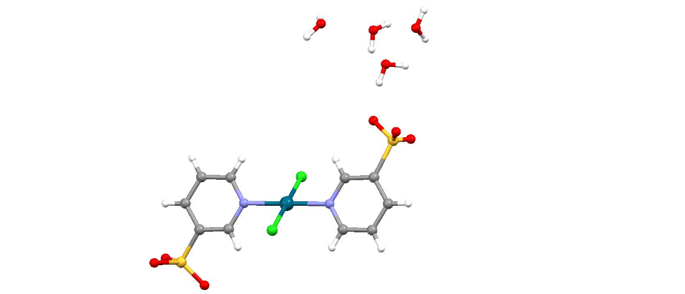
Preparation of Linker PdCl₂(Py-3-SO₃H)₂ (complex 3):

Scheme 3: Synthetic route to prepare the water soluble linker complex.^{[3]}
To an aqueous solution of pyridine-3-sulfonic acid (1.60g, 10mmol) in water (10 ml), an aqueous solution of palladium (II) chloride (0.88g, 5 mmol) was added. The reaction mixture was then heated at 80ºC for 2 hours. After that the solution was filtered and dried under vacuum to obtain a brown liquid.
1H-NMR: ¹H NMR (400 MHz, D₂O) δ 9.048 (d), 8.81 (d), 8.25 (d), 7.59(dd)
13C-NMR: ¹³C NMR (400 MHz, D₂O) δ 154.62, 149.66, 141.22, 137.12, 126.19
ESI-MS: 460.87 [M-Cl]⁺ , 478. 86 [{M-Cl}+H₂O]⁺

Formation of Unimolecular Assemblies: MA1−MA4 were obtained by iterative spin-coating of the aqueous solutions of Na₂PdCl₄ and PdCl₂(Py-3-SO₃H)₂ and aqueous solution of the complexes 1 and 2. Complex 1 is completely soluble in water at room temperature, whereas 5% MeOH (95% H₂O) was used for complex 2. An aqueous solution of PdCl₂(Py-3-SO₃H)₂ or Na₂PdCl₄ (4.0 mM) was used for the formation of molecular assemblies MA1−MA4. MA1 and MA2 was obtained by iterative spin-coating of aqueous solutions of Na₂PdCl₄ and aqueous solution of complex 1 and 2, whereas MA3 and MA4 was obtained from the aqueous solution of PdCl₂(Py-3-SO₃H)₂ with complex 1 and 2 respectively.

Complex | Linker Na₂PdCl₄ | Linker PdCl₂(Py-3-SO₃H)₂
1 | MA1 | MA3
2 | MA2 | MA4

The aqueous solution of the linker Na₂PdCl₄ or PdCl₂(Py-3-SO₃H)₂ was dropcasted onto the FTO/glass substrates (2 cm × 2 cm). Subsequently, the substrate was spun at 500 rpm for 10 s and then at 1000 rpm for 30 s. Next, a solution of the corresponding complex 1−2 was dropcasted after 80 s onto the substrates, which were spun as above. The substrates were then immersed in methanol for 30 s and were dried under a gentle stream of air. The linker deposition and subsequent complex (1−2) deposition step is referred to as a single deposition cycle. For the formation of MA1 and MA3, the deposition cycle was repeated 26 times. For the formation of MA2 and MA4, the deposition cycle was repeated 16 times. The deposition of the first layer of PdCl₂ was found to be necessary for the binding of metal complexes 1−2 to the substrate surface.
Fabrication of Laminated Electrochromic Devices: A layered architecture was used to construct laminated sandwich cells based on MA1-MA4 on FTO/glass substrates. The modified FTO-coated glass substrates served as the working electrode, and a corresponding bare substrate served as the reference and counter electrodes. A frame of 210-μm-thick double-sided tape (3M 9088) was attached to the working electrode (2 cm × 2 cm) for FTO/glass substrates leaving an exposed edge (1−2 mm) for silver paste or copper tape contacts. Contacts were also connected to an edge (1−2 mm) of the counter electrode. The two electrodes were placed with the two conducting faces facing each other. The electrolyte gel (70:20:7:3 wt% ACN/PC/PMMA/lithium perchlorate salt) was injected using a syringe between the two electrodes. The edges of the devices were sealed using epoxy glue. The device was then connected to a potentiostat, and the electrochromic properties were investigated.

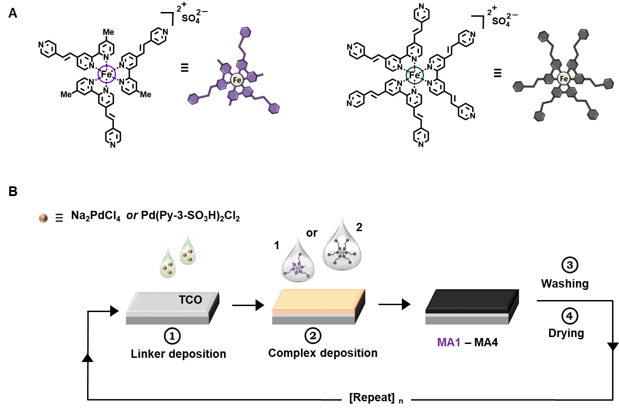

Figure 1: (A) Molecular structures of the electrochromic complexes 1 and 2, and schematic of the thin films.
(B) General presentation about the fabrication of the electrochromic molecular assemblies (MAs). The MAs were formed by depositing alternating layers of an aqueous solution of different Pd-linkers and complexes 1−2 by spin-coating (n = 16-26). Fluorine-doped transparent conductive oxides (FTO) on glass was used as substrates.

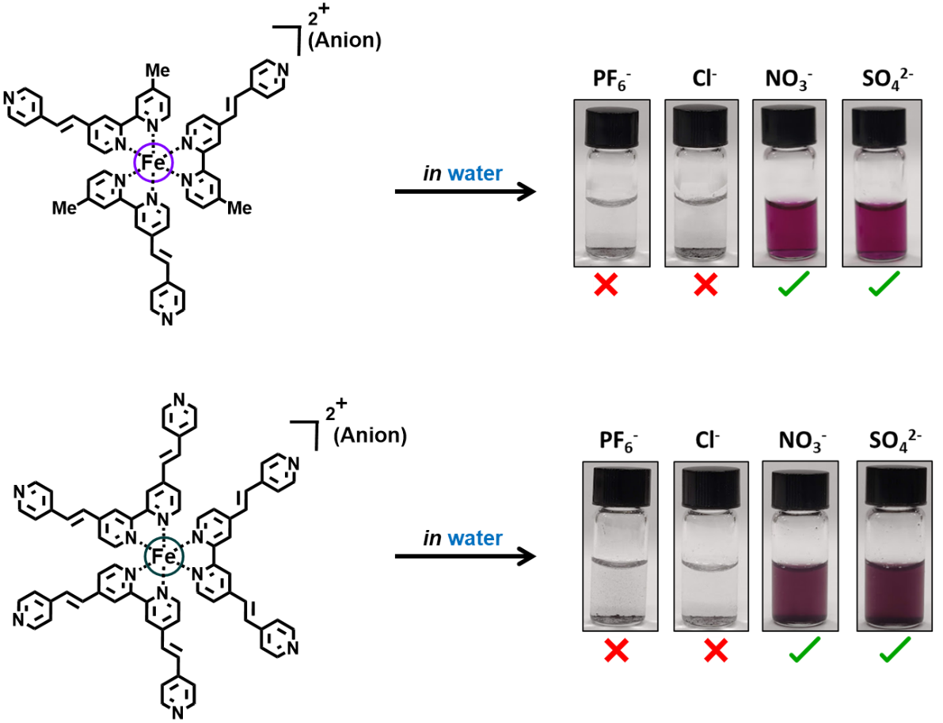

Figure 2: Anion dependence of aqueous solubility for the iron(II)-polypyridyl complexes 1 and 2.

Fabrication of the electrochromic molecular assembly MA1 from water.
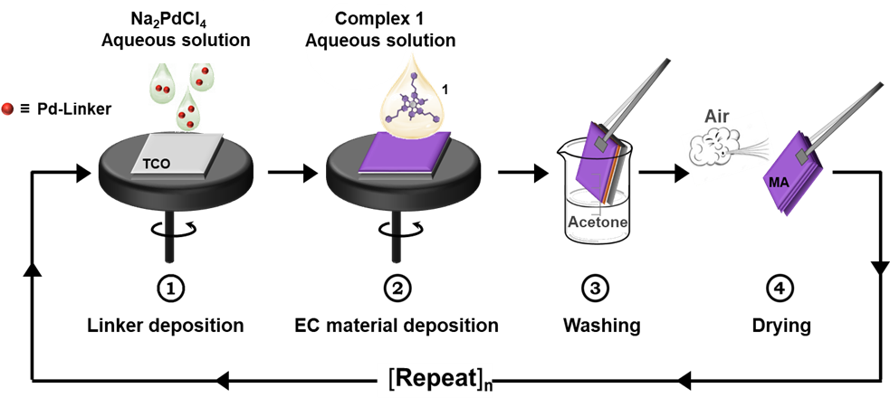
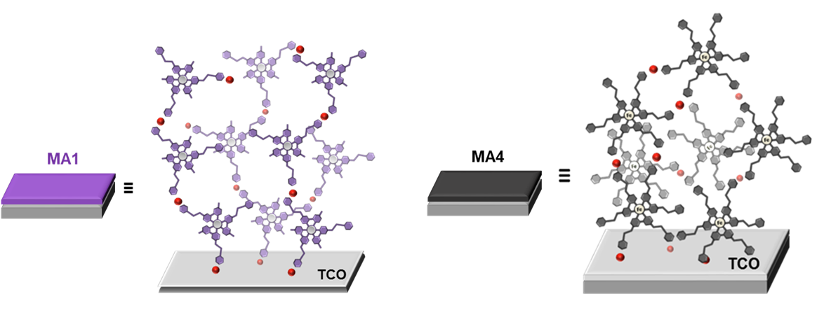
Figure 3: (a) Fabrication of the electrochromic molecular assembly MA1. (b) The MA1 was formed by depositing alternating layers of aqueous Na₂PdCl₄ and aqueous solution of complexes 1 by spin-coating (n = 26). Transparent conductive oxides (TCOs) on glass was used as substrates.

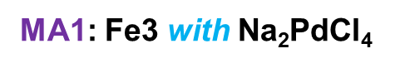
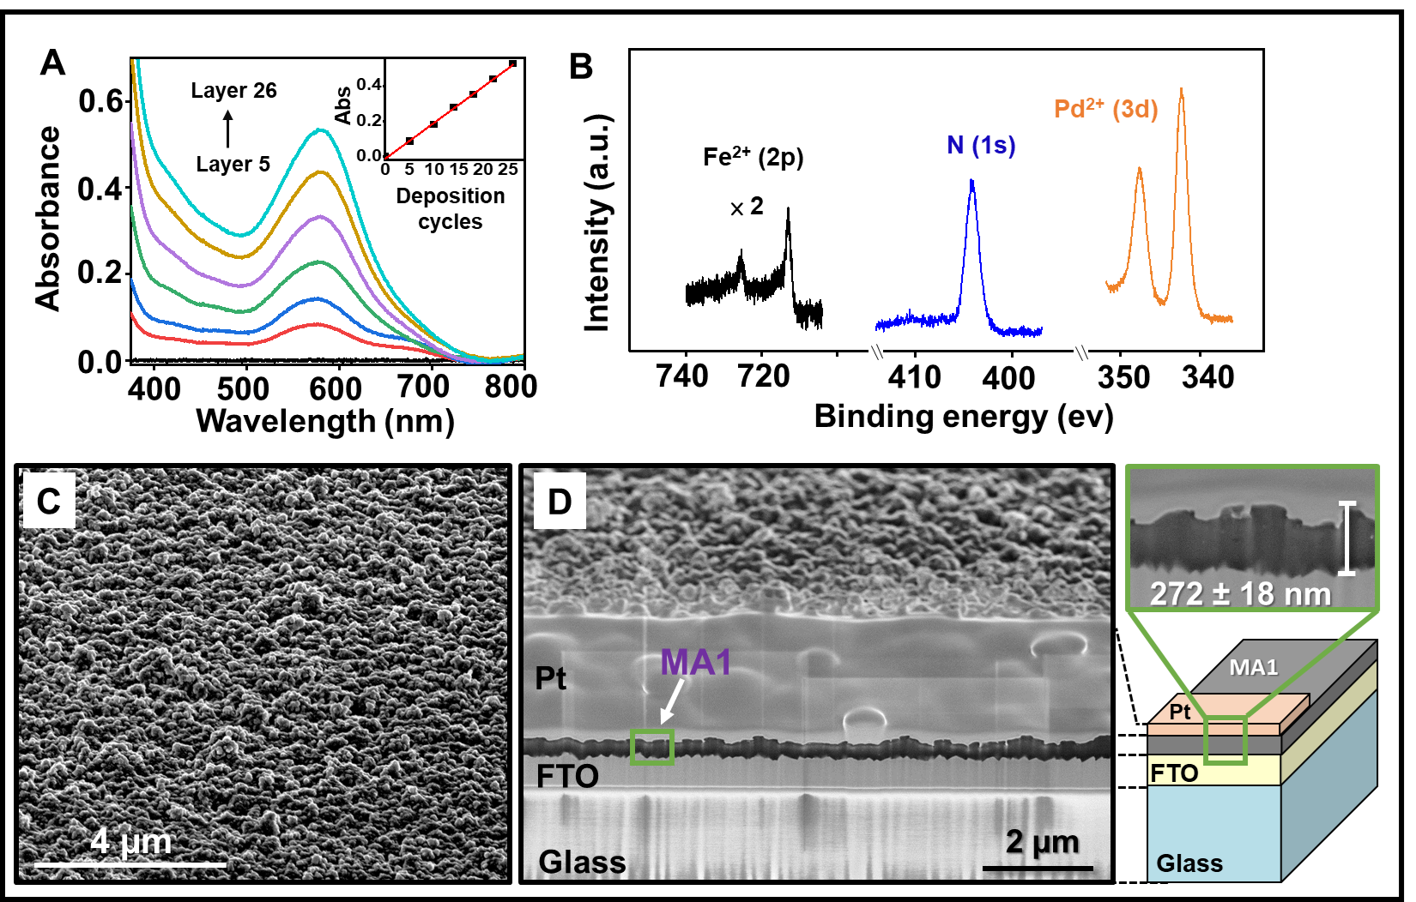

Figure 4: Surface characterization of [MA1|FTO/glass 10 Ω/□] after 26 deposition cycles. (A) Ex situ absorption spectra recorded during the formation of MA1 by alternating deposition cycles of Na₂PdCl₄ and complex 1. A bare FTO substrate was used for the baseline (black). Inset: Absorbance intensity of the MLCT band (λ_{max} = 580 nm) vs the number of deposition cycles, showing a linear growth behavior. (B) Normalized X-ray photoelectron
spectroscopy (XPS) spectra showing the Fe²⁺ 2p, N 1s, and Pd²⁺ 3d regions. (C, D) Scanning electron microscopy (SEM) images: (C) top view and (D) cross section of [MA1|FTO/glass 10 Ω/□] that was milled by a 30 keV Ga⁺ focused ion beam (FIB). A Pt coating was used to prevent ion beam damage (the surface was first covered with a 3 nm thick layer of iridium).


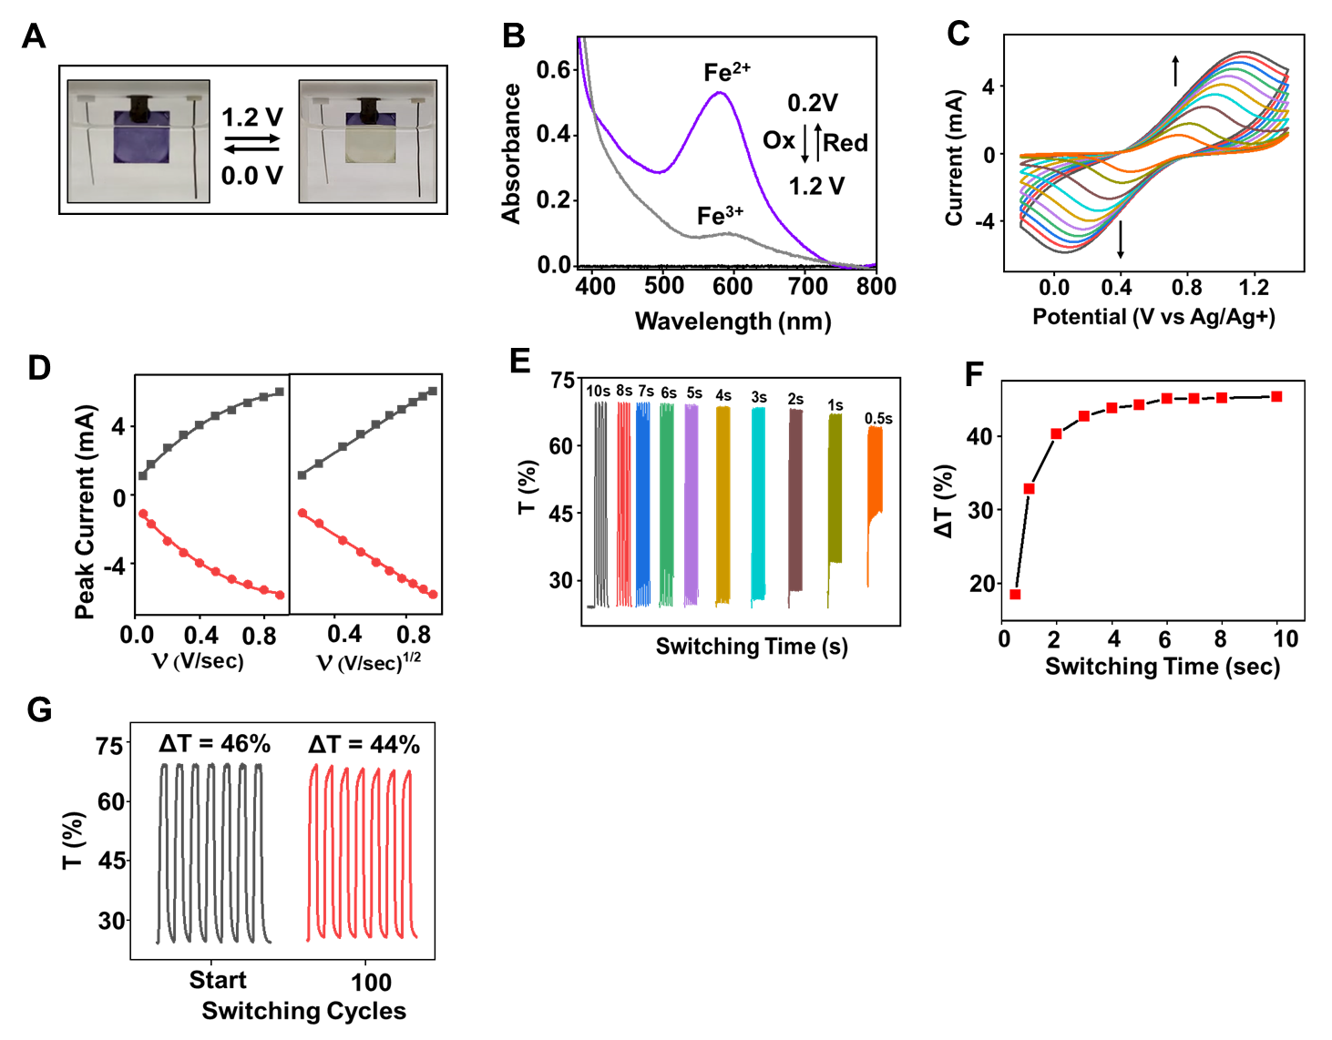
Figure 5: (A) Photographs of MA1 (2 cm × 2 cm) in the reduced (colored) and oxidized (bleached) states in 0.1M aqueous solution of LiClO₄. (B) Absorption spectra corresponding to two consecutive oxidation and reduction cycles of MA1. Bare FTO substrates were used for the baseline (black). (C) Cyclic voltammograms (CVs) with scan rates of 0.05−0.9 V/s. The arrows indicate the increase in the current with an increase in the scan rate. Substrate dimension: 2 cm × 1 cm. (D) Exponential and linear correlations between the peak currents (I) vs scan rates (ν) (left) and I vs ν^{1/2} (right), respectively, during oxidation (top) and reduction (bottom) (R2 > 0.99 for all fits). (E) SEC measurements of [MA1 | FTO/glass] (2 cm × 1 cm) using double potential steps: 0.2 V to 1.4 V at
different switching times in 0.1 M LiClO₄ /H₂O electrolyte. (F) Dependence of the contrast ratio (ΔT) on the switching time.



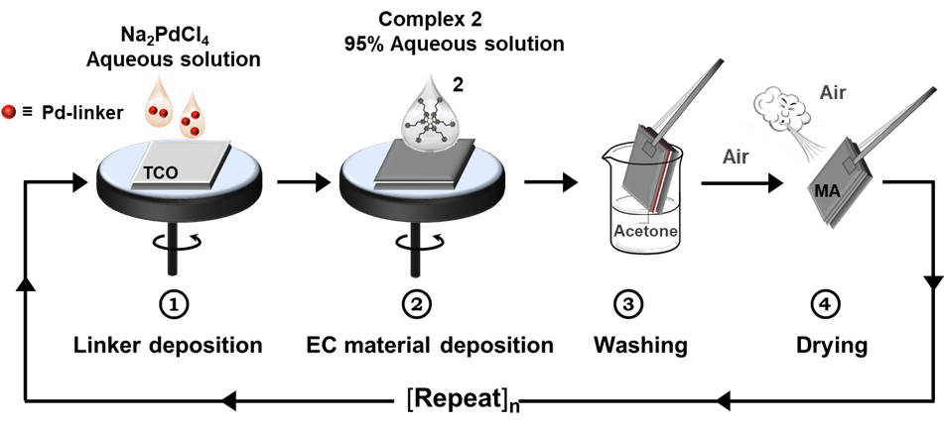
Fabrication of the electrochromic molecular assembly MA2 from water.
Figure 6: (a) Fabrication of the electrochromic molecular assembly MA2. (b) The MA2 was formed by depositing alternating layers of aqueous Na₂PdCl₄ and aqueous solution of complex 2 by spin-coating (n = 16). Transparent conductive oxides (TCOs) on glass was used as substrates.

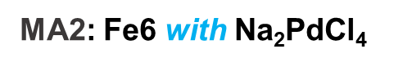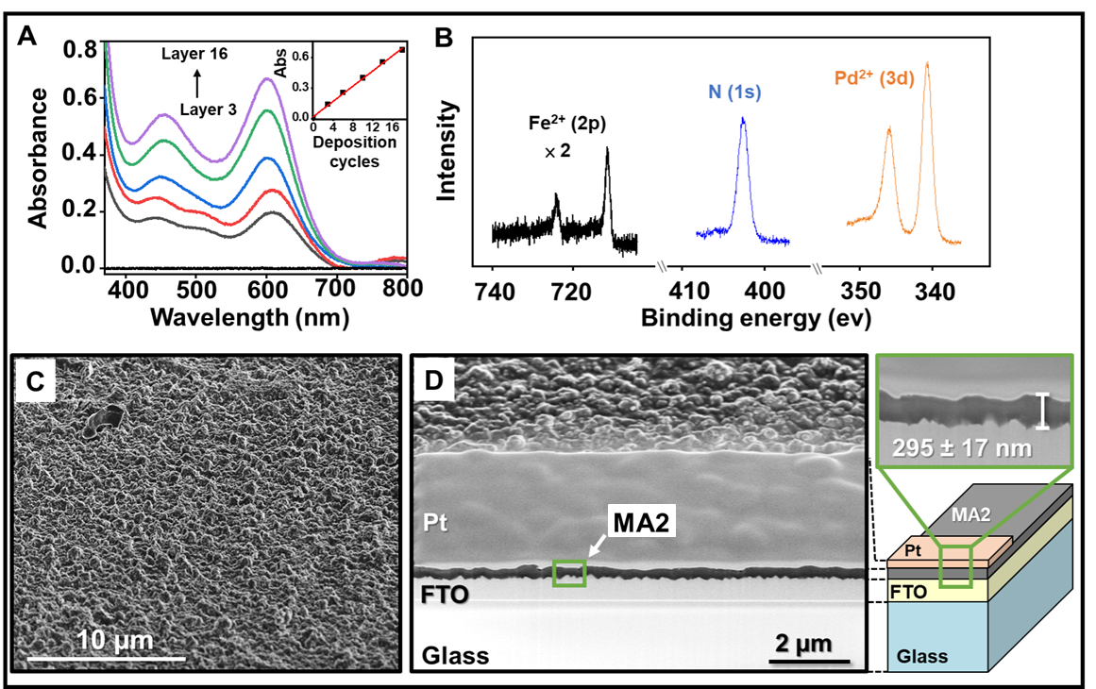

Figure 7: Surface characterization of [MA2|FTO/glass 10 Ω/□] after 16 deposition cycles. (A) Ex situ absorption spectra recorded during the formation of MA2 by alternating deposition cycles of Na₂PdCl₄ and complex 2. A bare FTO substrate was used for the baseline (black). Inset: Absorbance intensity of the MLCT band (λ_{max} = 600 nm) vs the number of deposition cycles, showing a linear growth behavior. (B) Normalized X-ray photoelectron spectroscopy (XPS) spectra showing the Fe²⁺ 2p, N 1s, and Pd²⁺ 3d regions. (C, D) Scanning electron microscopy (SEM) images: (C) top view and (D) cross section of [MA3|FTO/glass 10 Ω/□] that was milled by a 30 keV Ga⁺ focused ion beam (FIB). A Pt coating was used to prevent ion beam damage (the surface was first covered with a 3 nm thick layer of iridium).



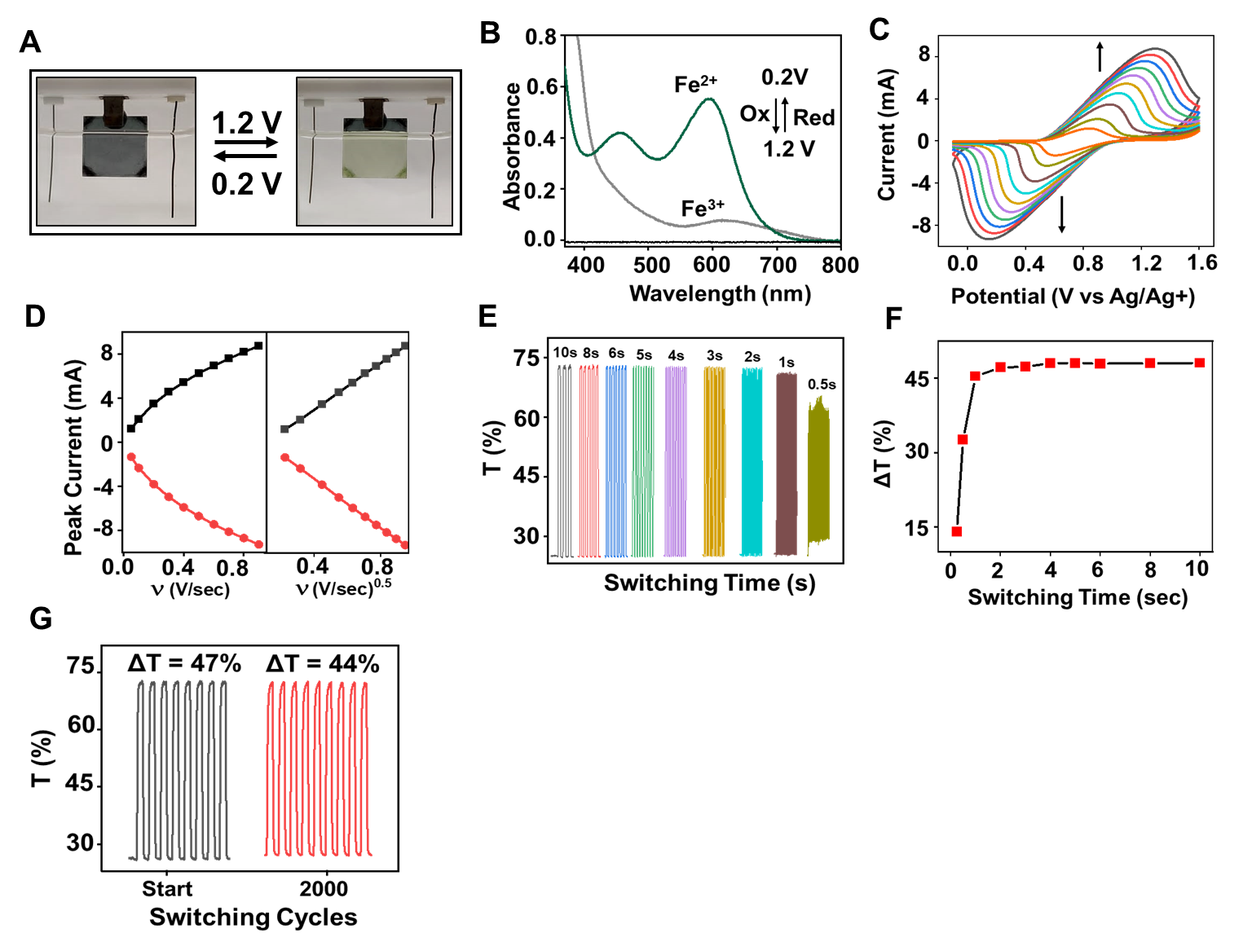
Figure 8: (A) Photographs of MA2 (2 cm × 2 cm) in the reduced (colored) and oxidized (bleached) states in 0.1M aqueous solution of LiClO₄. (B) Absorption spectra corresponding to two consecutive oxidation and reduction cycles of MA2. Bare FTO substrates were used for the baseline (black). (C) Cyclic voltammograms (CVs) with scan rates of 0.05−0.9 V/s. The arrows indicate the increase in the current with an increase in the scan rate. Substrate dimension: 2 cm × 1 cm. (D) Exponential and linear correlations between the peak currents (I) vs scan rates (ν) (left) and I vs ν^{1/2} (right), respectively, during oxidation (top) and reduction (bottom) (R2 > 0.99 for all fits). (E) SEC measurements of [MA2 | FTO/glass] (2 cm × 1 cm) using double potential steps: 0.0 V to 1.5 V at
different switching times in 0.1 M LiClO₄ /H₂O electrolyte. (F) Dependence of the contrast ratio (ΔT) on the switching time.

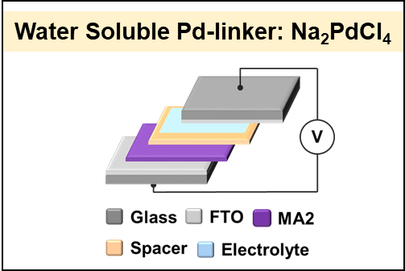
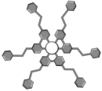
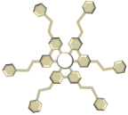
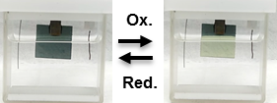
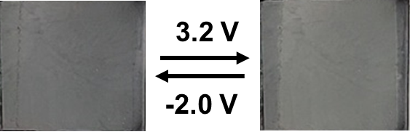


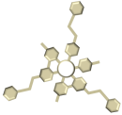
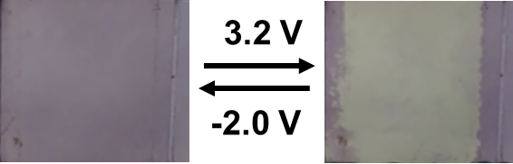
Figure 9: (A) Schematic representation of the ECD of [MA1 and MA2│FTO/glass], using bare FTO/glass as the counter electrode. FTO/glass is used as substrates for both electrodes, which are separated by a gel electrolyte (LiClO4/PMMA/ACN) and a spacer (double-sided tape) (B) Photographs of the colored and bleached states (2 cm × 2 cm) for ECD of MA2, which is not completely switching. (C) Photographs of the colored and bleached states (2 cm × 2 cm) for ECD of MA1, which is only stable for 10 cycles.
(a)
No Complete Switching
10 Layers in Device
ECD: FTO / MA2 //FTO
Electrolyte: (LiClO₄ + PMMA) in ACN.
(b)
Electrolyte: (LiClO₄ + PMMA) in ACN.
Stability: Only 10 cycles
ECD: FTO / MA1 //FTO
26 Layers in Device
(c)
Laminated Device from MA1 and MA2


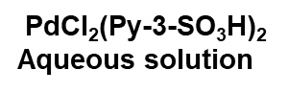


Figure 10: (a) Fabrication of the electrochromic molecular assembly MA3. (b) The MA3 was formed by depositing alternating layers of aqueous PdCl₂(py-3-SO₃H)₂ and aqueous solution of complex 1 by spin-coating (n = 16). Transparent conductive oxides (TCOs) on glass was used as substrates.
Fabrication of the electrochromic molecular assembly MA3 from water.
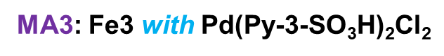

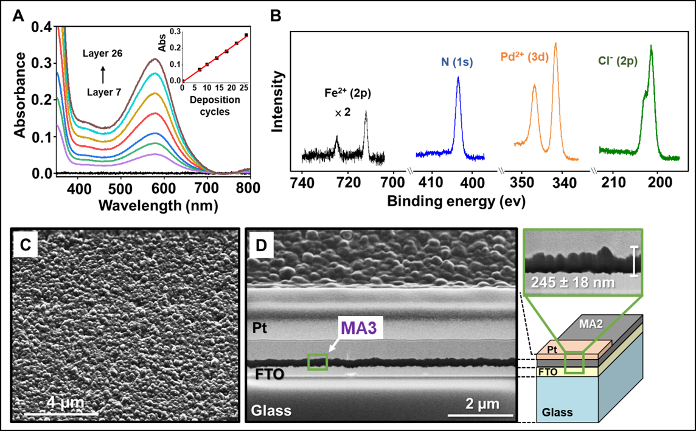
Figure 11: Surface characterization of [MA3|FTO/glass 10 Ω/□] after 26 deposition cycles. (A) Ex situ absorption spectra recorded during the formation of MA3 by alternating deposition cycles of Pd(Py-3-SO₃H)Cl₄ and complex 1. A bare FTO substrate was used for the baseline (black). Inset: Absorbance intensity of the MLCT band (λ_{max} = 575 nm) vs the number of deposition cycles, showing a linear growth behavior. (B) Normalized X-ray photoelectron spectroscopy (XPS) spectra showing the Fe²⁺ 2p, N 1s, Cl⁻ 2p, and Pd²⁺ 3d regions. (C, D) Scanning electron microscopy (SEM) images: (C) top view and (D) cross section of [MA2|FTO/glass 10 Ω/□] that was milled by a 30 keV Ga⁺ focused ion beam (FIB). A Pt coating was used to prevent ion beam damage (the surface was first covered with a 3 nm thick layer of iridium).



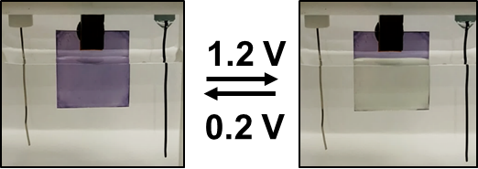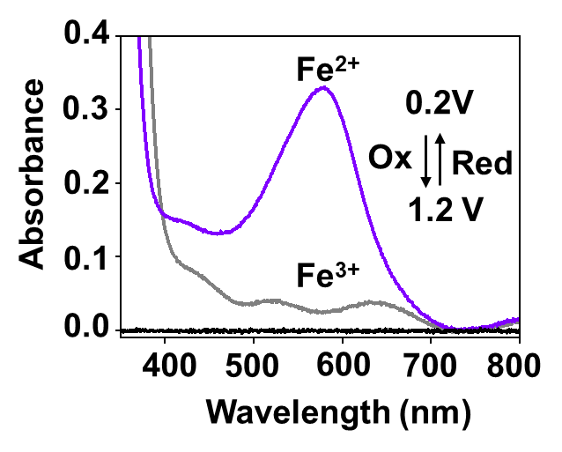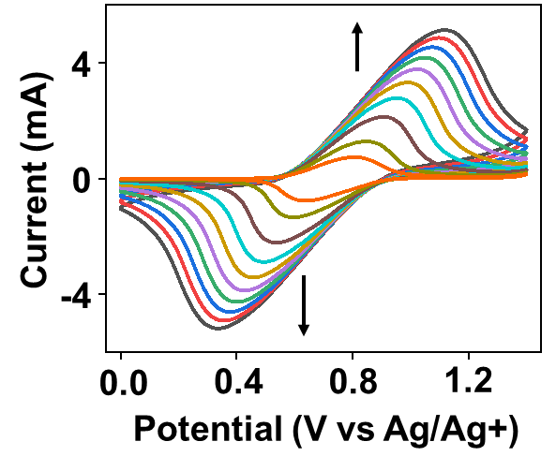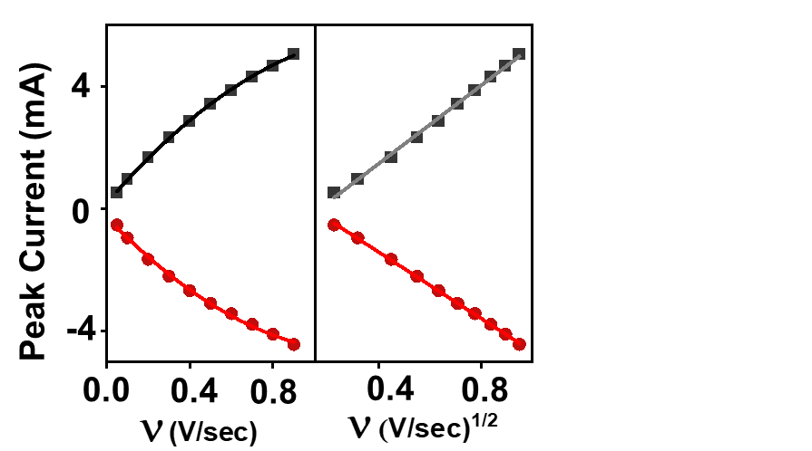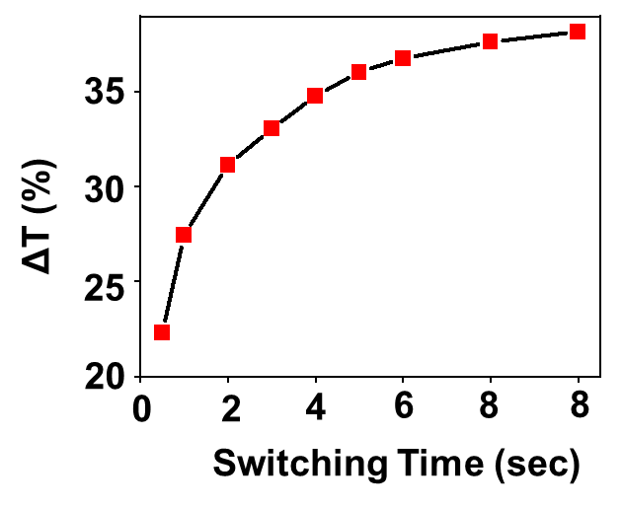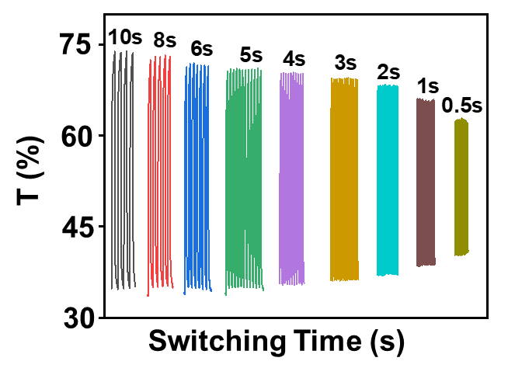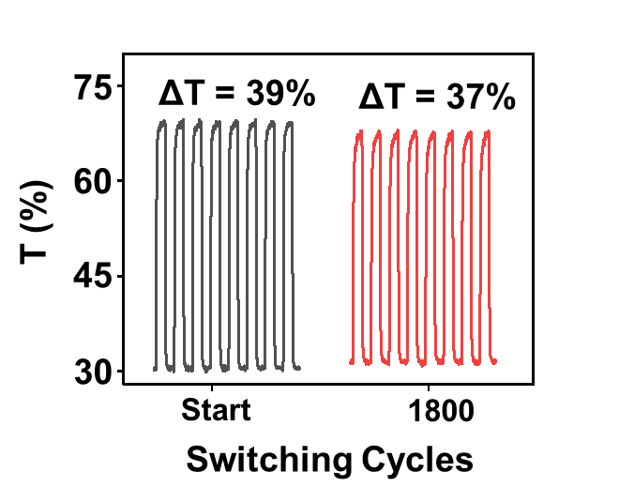
A
B
C
D
E
F
G
Figure 12: (A) Photographs of MA3 (2 cm × 2 cm) in the reduced (colored) and oxidized (bleached) states in 0.1M aqueous solution of LiClO₄. (B) Absorption spectra corresponding to two consecutive oxidation and reduction cycles of MA3. Bare FTO substrates were used for the baseline (black). (C) Cyclic voltammograms (CVs) with scan rates of 0.05−0.9 V/s. The arrows indicate the increase in the current with an increase in the scan rate. Substrate dimension: 2 cm × 1 cm. (D) Exponential and linear correlations between the peak currents (I) vs scan rates (ν) (left) and I vs ν^{1/2} (right), respectively, during oxidation (top) and reduction (bottom) (R2 > 0.99 for all fits). (E) SEC measurements of [MA3 | FTO/glass] (2 cm × 1 cm) using double potential steps: 0.2 V to 1.4 V at different switching times in 0.1 M LiClO₄ /H₂O electrolyte. (F) Dependence of the contrast ratio (ΔT) on the switching time.
Fabrication of the electrochromic molecular assembly MA4 from water.




Figure 13: (a) Fabrication of the electrochromic molecular assembly 4 (MA4). (b) The MA4 was formed by depositing alternating layers of aqueous PdCl₂(py-3-SO₃H)₂ and aqueous solution of complex 2 by spin-coating (n = 16). Transparent conductive oxides (TCOs) on glass was used as substrates.

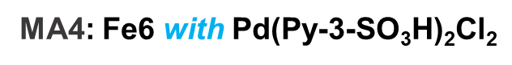

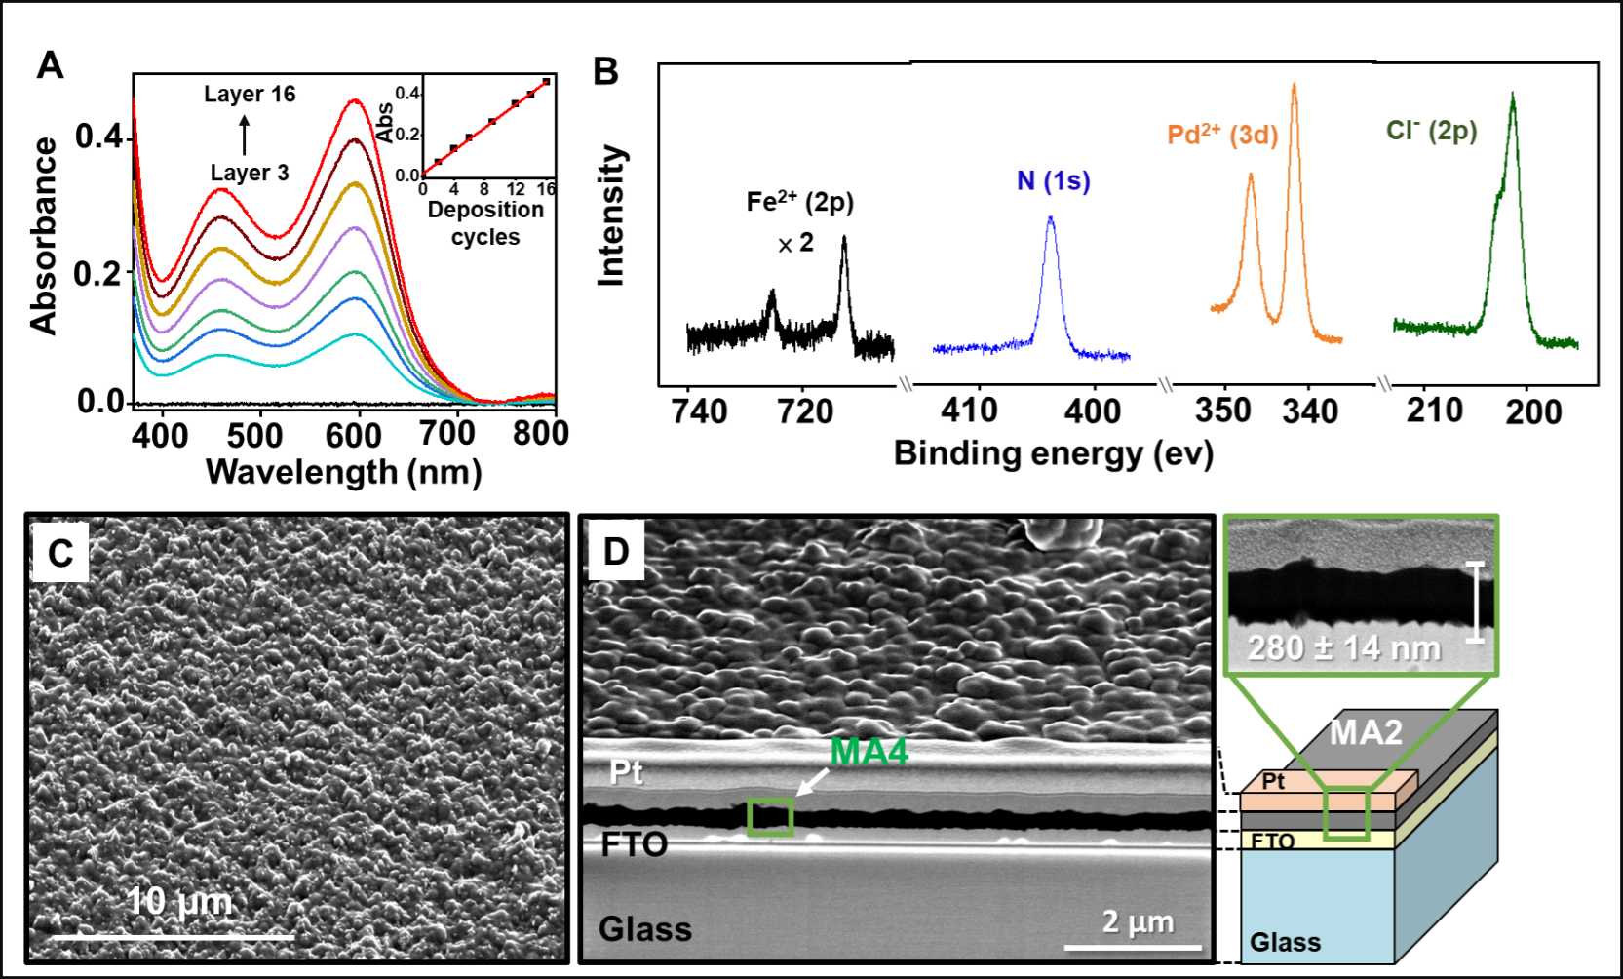

Figure 14: Surface characterization of [MA4|FTO/glass 10 Ω/□] after 16 deposition cycles. (A) Ex situ absorption spectra recorded during the formation of MA4 by alternating deposition cycles of Pd(Py-3-SO₃H)Cl₄ and complex 2. A bare FTO substrate was used for the baseline (black). Inset: Absorbance intensity of the MLCT band (λ_{max} = 600 nm) vs the number of deposition cycles, showing a linear growth behavior. (B) Normalized X-ray photoelectron spectroscopy (XPS) spectra showing the Fe²⁺ 2p, N 1s, and Pd²⁺ 3d regions. (C, D) Scanning electron microscopy (SEM) images: (C) top view and (D) cross section of [MA4|FTO/glass 10 Ω/□] that was milled by a 30 keV Ga⁺ focused ion beam (FIB). A Pt coating was used to prevent ion beam damage (the surface was first covered with a 3 nm thick layer of iridium).



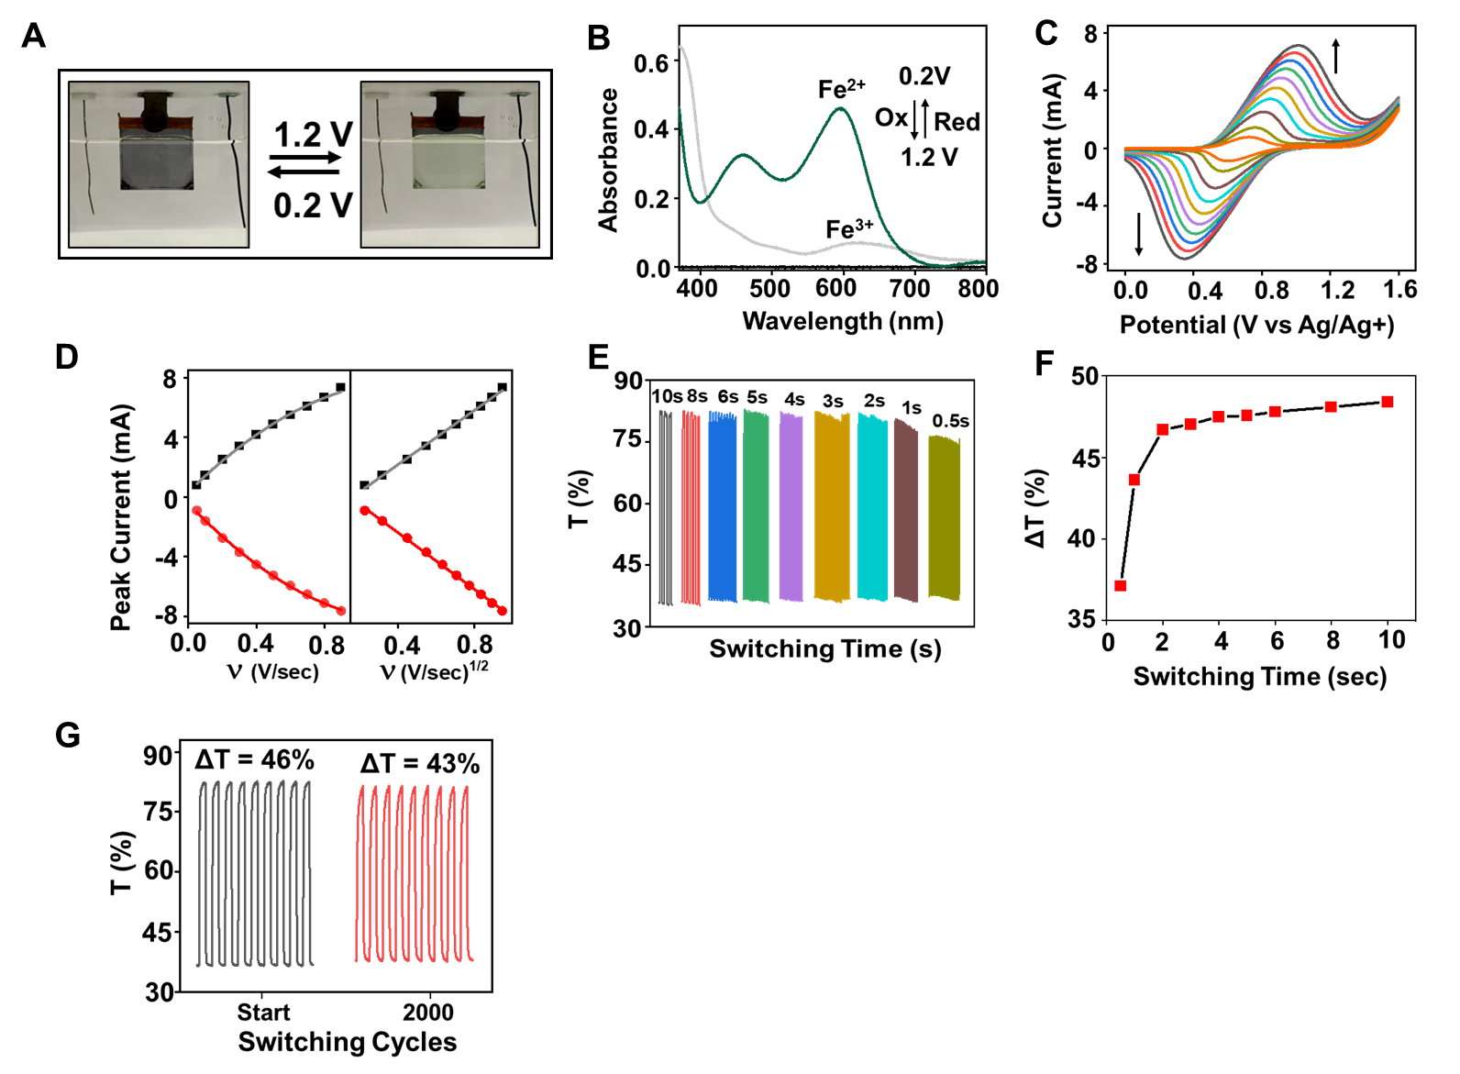

Figure 15: (A) Photographs of MA4 (2 cm × 2 cm) in the reduced (colored) and oxidized (bleached) states in 0.1M aqueous solution of LiClO₄. (B) Absorption spectra corresponding to two consecutive oxidation and reduction cycles of MA4. Bare FTO substrates were used for the baseline (black). (C) Cyclic voltammograms (CVs) with scan rates of 0.05−0.9 V/s. The arrows indicate the increase in the current with an increase in the scan rate. Substrate dimension: 2 cm × 1 cm. (D) Exponential and linear correlations between the peak currents (I) vs scan rates (ν) (left) and I vs ν^{1/2} (right), respectively, during oxidation (top) and reduction (bottom) (R2 > 0.99 for all fits). (E) SEC measurements of [MA4 | FTO/glass] (2 cm × 1 cm) using double potential steps: 0.0 V to 1.5 V at different switching times in 0.1 M LiClO₄ /H₂O electrolyte. (F) Dependence of the contrast ratio (ΔT) on the switching time.

ECD performance without ion storage layer: MA4 : Fe6 with Pd(Py-3-SO₃H)Cl₂

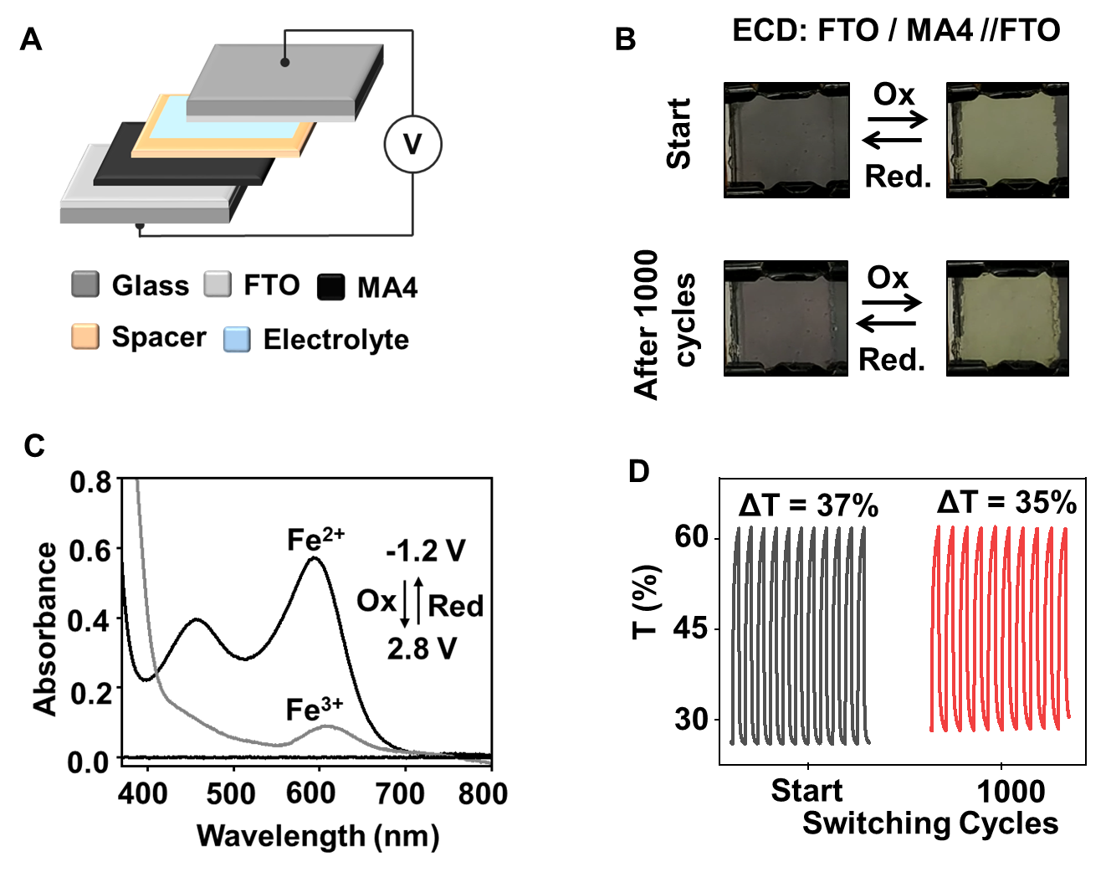
Figure 16: (A) Schematic representation of the ECD of [MA4│FTO/glass], using bare FTO/glass as the counter electrode. FTO/glass is used as substrates for both electrodes, which are separated by a gel electrolyte (LiClO4/PMMA/ACN) and a spacer (double-sided tape) (B) Photographs of the colored and bleached states (2 cm × 2 cm). (C) Absorption spectra corresponding to two consecutive oxidation and reduction cycles. Bare FTO substrates were used for the baseline (black). (D) SEC performance using double potential steps: -1.2 V to +2.8 V at λ_{max} = 595 nm, start and after 1000 cycles

ECD performance without ion storage layer: MA3 : Fe3 with Pd(Py-3-SO₃H)Cl₂
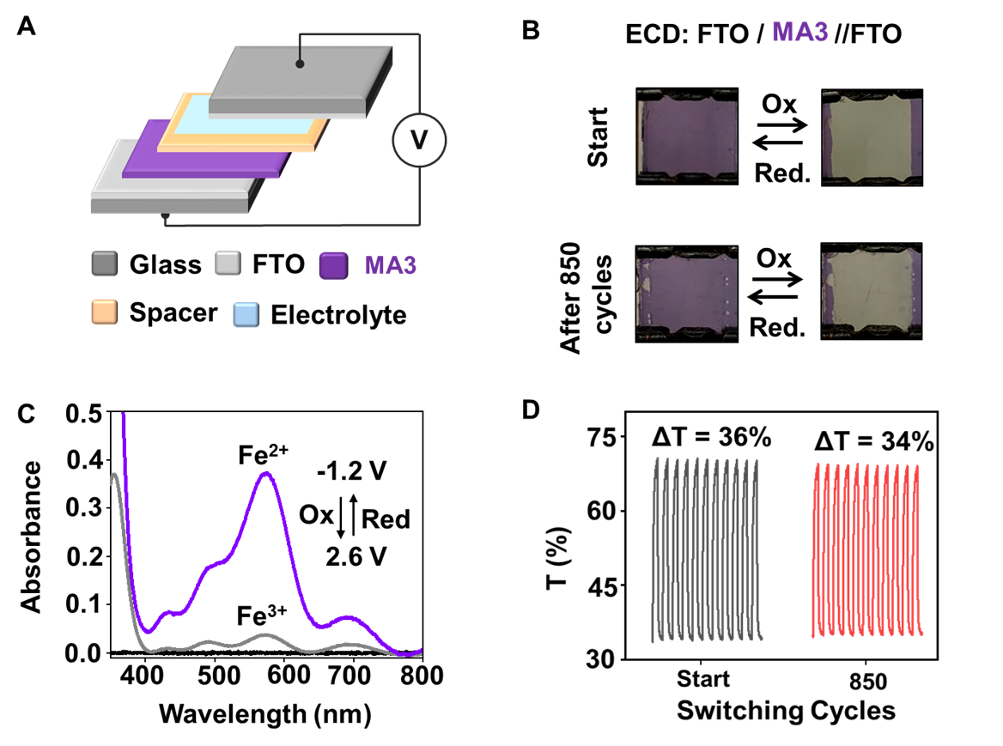

Figure 17: (A) Schematic representation of the ECD of [MA3│FTO/glass], using bare FTO/glass as the counter electrode. FTO/glass is used as substrates for both electrodes, which are separated by a gel electrolyte (LiClO4/PMMA/ACN) and a spacer (double-sided tape) (B) Photographs of the colored and bleached states (2 cm × 2 cm). (C) Absorption spectra corresponding to two consecutive oxidation and reduction cycles. Bare FTO substrates were used for the baseline (black). (D) SEC performance using double potential steps: -1.2 V to +2.6 V at λ_{max} = 570 nm, start and after 850 cycles

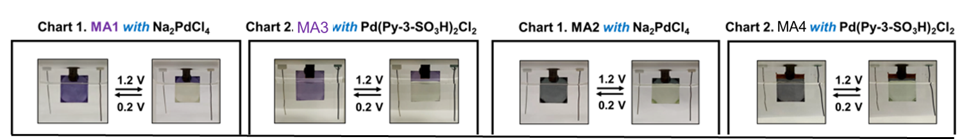

Table 1: Summary of the molecular assemblies (MA1-MA4) of the complex 1 and 2 with two different Pd-linker and their stability as EC film and ECD.

Complex | Linker | Molecular Assembly | EC Film Stability (95%) (in cycles) | ECDs Stability (95%)  (in cycles)
1 | Na₂PdCl₄ | MA1 | 3000 | 10
 | PdCl₂(Py-3-SO₃H)₂ | MA3 | 2000 | 1200
2 | Na₂PdCl₄ | MA2 | 2000 | ×
 | PdCl₂(Py-3-SO₃H)₂ | MA4 | 1800 | 850

Table 2: Compare various parameters for the molecular assemblies MA1-MA4 of the complex 1 and 2 with Pd-linkers

Parameters | Linker = Na₂PdCl₄ |  | Linker = Pd(Cl)₂(3-pySO₃H)₂
 | Complex 1  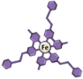 | Complex 2  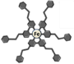 | Complex 1   | Complex 2  
λ_{max} (nm) | 579 | 598 | 579 | 598
ΔT% | 46 | 47 | 39 | 46
Stability (95%)  ( in cycles) | 100 | 2000 | 1800 | 2000
Color | Purple | Gray | Purple | Gray
E_{1/2} (V) | 0.607 | 0.723 | 0.720 | 0.668
Diffusion Coefficient  (cm²/sec) | Ox: 2.14×10⁻⁸ | Ox: 1.77×10⁻⁹ | Ox: 1.45×10⁻⁸ | Ox: 2.35×10⁻⁹
 | Red: 1.93×10⁻⁸ | Red: 1.17×10⁻⁹ | Red: 1.57×10⁻⁸ | Red: 2.04×10⁻⁹
Switching time for Oxdn | 1.35 sec | 1.78 | 0.91 | 1.06
Switching time for Redn | 1.26 sec | 1.53 | 0.82 | 0.96
No of molecules on the active surface from CV  (molecules/cm²) | 1.05×10¹⁶ | 1.21×10¹⁶ | 7.25×10¹⁵ | 9.15×10¹⁵
No of molecules on the active surface from UV  (molecules/cm²) | 1.75×10¹⁶ | 1.85×10¹⁶ | 8.75×10¹⁵ | 10.25×10¹⁵

References:

(S1) Shankar, S.; Lahav, M.; van der Boom, M. E. J. Am.Chem. Soc. 2015, 137, 4050-4053.
(S2) Malik, N.; Dov, N. E.; Ruiter, G. de; Lahav, M.; van der Boom, M. E., ACS Appl. Mater. Interfaces 2019, 11, 22858.

